# Brainstorm

## Before you collaborate

A little bit of preparation goes a long way with this session. Here’s what you need to do to get going.

#### 10 minutes

**1**

## Define your problem statement

What problem are you trying to solve? Frame your problem as a How Might We statement. This will be the focus of your brainstorm.

#### 5 minutes

**2**

## Brainstorm

sustainable smart city assistant using IBM granite model

#### 10 minutes

**3**

## Group ideas

our group could design and prototype a voice- and app-based AI assistant named

*EcoMate* that helps citizens live more sustainably within a smart city ecosystem. Each member could take on a role reflecting different technical and societal aspects:

#### 20 minutes

**4**

## Prioritize

Defining features and user types

* Creating a basic prototype
* Assigning tasks based on team strengths

**20 minutes**

# & idea prioritization

**PROBLEM**

Cities are growing fast, but many people lack tools to make eco-friendly choices day to day. A **Sustainable Smart City Assistant** bridges this gap by using real-time data to guide better habits—like saving energy, reducing waste, or navigating traffic—making urban life greener, smarter, and more livable.

For our brainstorming session, spark creativity by exploring assistant features like eco-alerts, smart commute planners, and waste sorting tools. Use prompts like “How can we make sustainability fun?” or “What would keep users coming back daily?” to guide ideas. Keep it open, playful, and purpose-driven to unlock your team’s best thinking.

**10 minutes** to prepare

**1 hour** to collaborate

**2-8 people** recommended

##### A Team gathering

Gather our team by setting clear roles, choosing the right collaboration tools, encouraging open idea-sharing, and keeping the shared goal—creating a smart, sustainable city assistant—at the heart of every discussion. A united, organized team is the first step toward an impactful project.

##### B Set the goal

To design and prototype an intelligent, user-friendly assistant that empowers urban citizens to adopt sustainable habits through real-time data, personalized recommendations, and seamless integration with smart city infrastructure—ultimately enhancing environmental awareness, public well-being, and city-wide sustainability.

##### C Learn how to use the facilitation tools

Use the Facilitation Superpowers to run a happy and productive session.

##### [Open article](https://support.mural.co/en/articles/2113740-facilitation-superpowers)

Afrid

##### Person 5

##### shajitha

**Person 6**

##### Divya

**Person 7**

**Nazeer**

**Person 8**

**+**

### Key rules of brainstorming

To run an smooth and productive session

Stay in topic. Defer judgment.

Encourage wild ideas. Listen to others.

### Importance

The importance of your **Sustainable**

Go for volume. If possible, be visual.

**Smart City**

###### **Assistant** project goes far beyond just cool tech—it's about building a future where cities are smarter *and*kinder to people and the planet

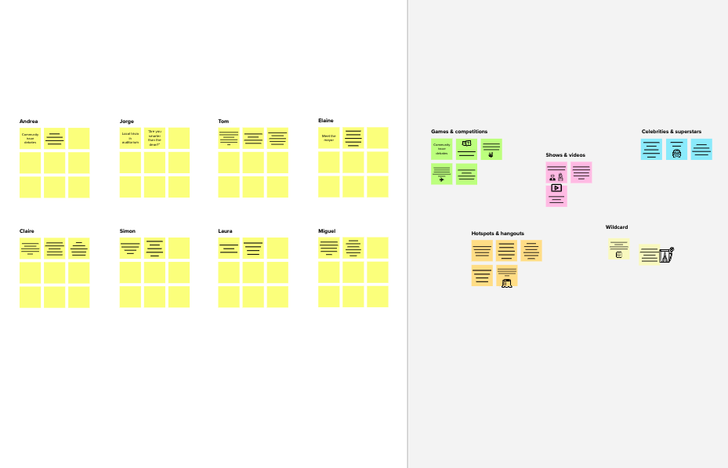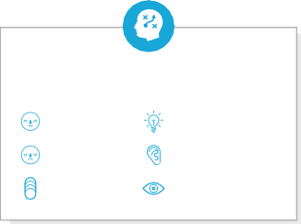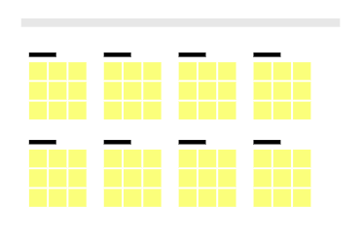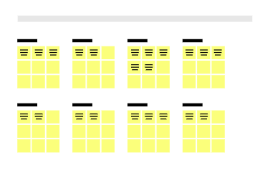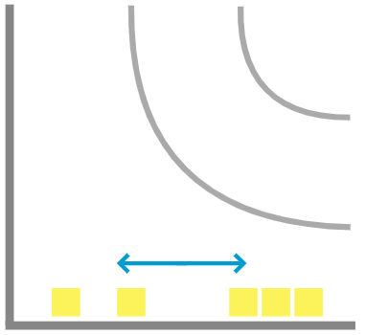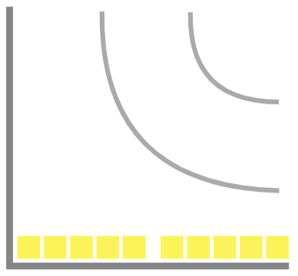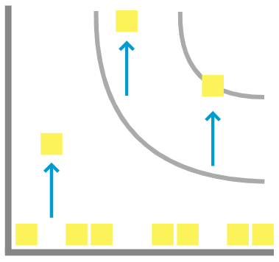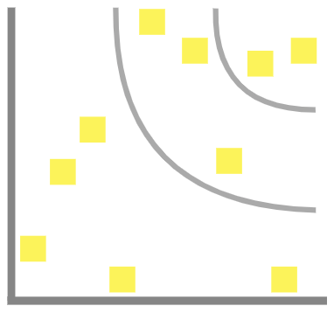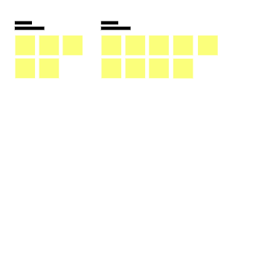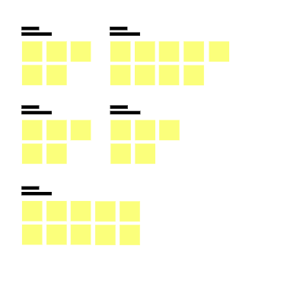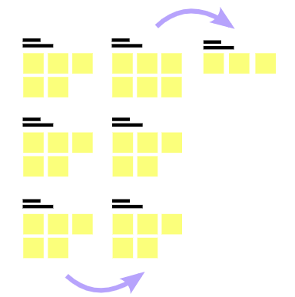

**Template**

**-**

### - Feasibility +

###### both the technical and practical sides

**Need some inspiration?**

See a finished version of this template to kickstart your work.

[**Open example**](https://app.mural.co/template/e5a93b7b-49f2-48c9-afd7-a635d860eba6/93f1b98d-b2d2-4695-8e85-7e9c0d2fd9b9)